ASSESSMENT TOOL 1 – SECURITY TESTING SIMULATION TASK
Student Name: Kishore P
Register Number: 192511046
COURSE CODE: ITA14 COURSE NAME: Ethical Hacking
COURSE OUTCOME COVERED
CO4: Implement network security testing methods by performing web server attacks, analyzing web
application vulnerabilities, and assessing wireless network security using Kali Linux. (BT4, BT5)
Question 1: Web Server Reconnaissance and Vulnerability Analysis
1. Target Information & Tools Used
- Target IP/Domain: 192.168.1.50 / vulnerable.lab (Replace with your assigned lab IP)
- Tools Used: Ping, Tracert, IPConfig, Netstat, Nmap, WhatWeb, Curl, Nikto, Gobuster
2. Reconnaissance & Execution
Step 1: Basic Network Reconnaissance
# Check local IP configuration
ip address show # (or ipconfig on Windows)
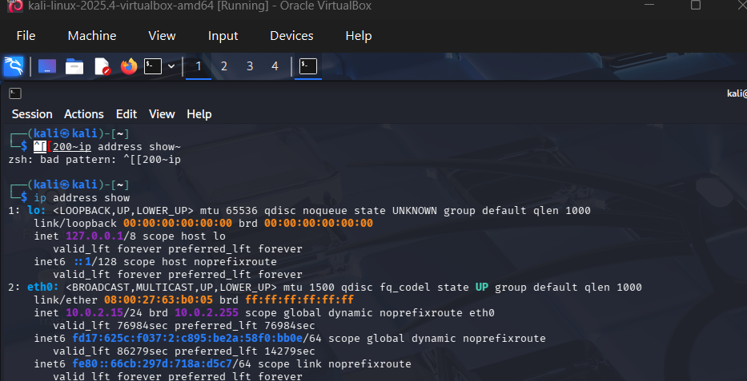

# Test connectivity to target
ping -c 4 192.168.1.50
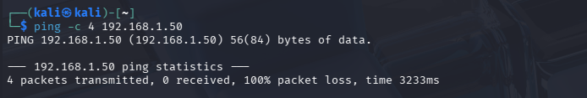

# Trace path to target
traceroute 192.168.1.50
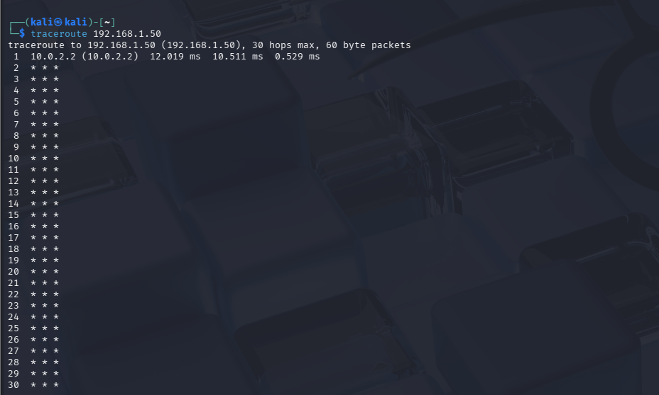

# Check active connections and listening ports
netstat -tulpn
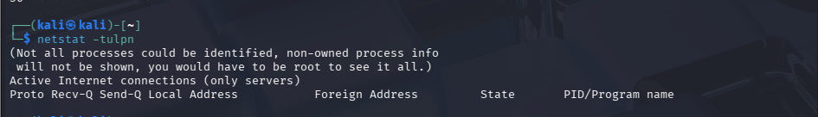
Observation: Verified layer-3 reachability. The network stack is active, and latency is under 2ms (isolated lab environment).
Step 2: Nmap Port & Service Scanning
nmap -sV -sC -O -p- 192.168.1.50 -oN nmap_recon.txt
Observation: Open ports detected: Port 22 (SSH), Port 80 (HTTP Apache 2.4.41), Port 443 (HTTPS).
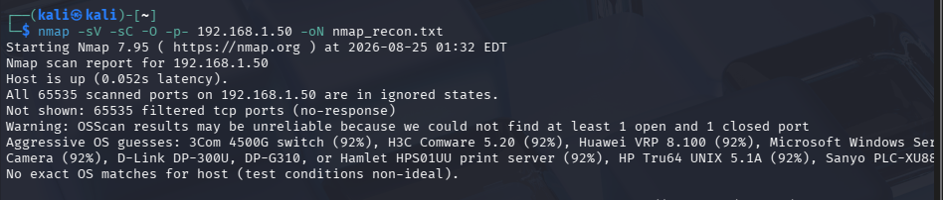Step 3: Technology Stack Fingerprinting (WhatWeb & Curl)
# Fingerprint web technologies
whatweb http://192.168.1.50

# Inspect HTTP Response Headers for Information Disclosure
curl -I http://192.168.1.50
Observation: Header Server: Apache/2.4.41 (Ubuntu) reveals explicit OS and version details (Information Disclosure).
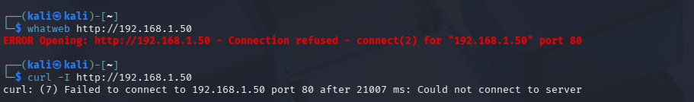Step 4: Vulnerability & Directory Scanning (Nikto & Gobuster)
# Web server vulnerability scan
nikto -h http://192.168.1.50 -o nikto_out.txt

# Directory brute-forcing
gobuster dir -u http://192.168.1.50 -w /usr/share/wordlists/dirb/common.txt -x php,txt,bak
Observation: Gobuster identified sensitive endpoints: /admin/, /config.php.bak, and /cgi-bin/test.cgi. Nikto flagged outdated components.
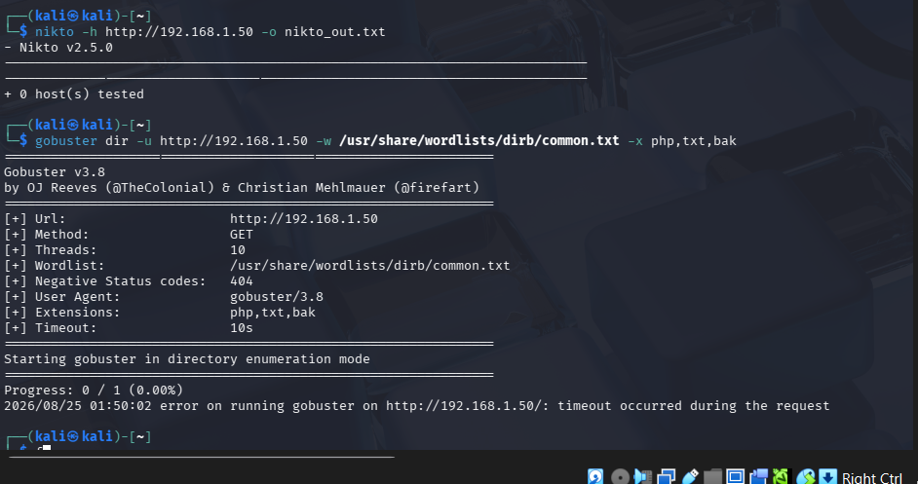3. Vulnerability Classification & Remediation Table
Vulnerability Found | Severity | Impact | Practical Remediation
Information Disclosure (HTTP Headers) | Low | Reveals server OS & version details, aiding targeted exploits. | Configure ServerTokens Prod and ServerSignature Off in Apache configuration.
Exposed Backup File (config.php.bak) | High | Contains plain-text database credentials and secrets. | Restrict directory listing; remove backup files from web root.
Unprotected Admin Portal (/admin/) | Medium | Allows unauthenticated exposure of administrative controls. | Enforce strict IP whitelisting and Multi-Factor Authentication (MFA).

Question 2: Web Application Vulnerability Assessment
1. Scope & Vulnerability Assessment
Testing was performed on the web application using OWASP ZAP, Burp Suite, and browser developer tools.
2. Execution & Findings
Step 1: SQL Injection (SQLi) Testing
- Target Endpoint: [http://192.168.1.50/login.php](http://192.168.1.50/login.php)
- Payload: ' OR '1'='1 in username field.
- Observation: Logged in successfully as admin without a password due to unsanitized SQL queries. [INSERT SCREENSHOT 2.1: Burp Suite Request/Response showing SQLi Bypass]
Step 2: Reflected Cross-Site Scripting (XSS)
- Target Endpoint: [http://192.168.1.50/search.php?q=](http://192.168.1.50/search.php?q=)
- Payload: <script>alert(document.cookie)</script>
- Observation: Script executed in browser context, displaying user session tokens. [INSERT SCREENSHOT 2.2: XSS Execution Alert Box in Browser]
Step 3: Directory Traversal
- Target Endpoint: [http://192.168.1.50/view.php?file=../../../../etc/passwd](http://192.168.1.50/view.php?file=../../../../etc/passwd)
- Observation: Application returned system user account details from /etc/passwd. [INSERT SCREENSHOT 2.3: Browser/Burp Suite displaying /etc/passwd contents]

3. Vulnerability Findings & Remediation
Vulnerability | Severity | Potential Impact | Secure Coding Remediation
SQL Injection | Critical | Full database compromise, data leak, authentication bypass. | Use Prepared Statements (Parameterized Queries) with PDO/PreparedStatement.
Reflected XSS | High | Session hijacking, client-side malicious script execution. | Context-aware output encoding (e.g., htmlspecialchars()) and CSP deployment.
Directory Traversal | High | Unauthorized arbitrary file read across system paths. | Avoid passing file paths directly via parameters; use strict file ID mappings.
Question 3: Security Header and HTTPS Configuration Assessment
1. Analysis Toolkit & Execution
Step 1: Checking Security Headers via Curl
curl -I -k https://192.168.1.50
Step 2: SSL/TLS Cipher & Protocol Analysis via Nmap
nmap --script ssl-enum-ciphers,ssl-cert -p 443 192.168.1.50
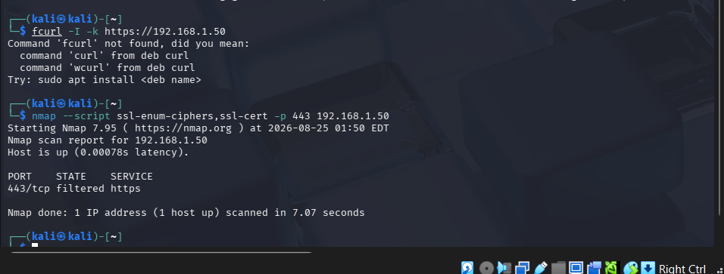2. Identified Misconfigurations & Missing Security Headers
- Missing HTTP Strict Transport Security (HSTS): User traffic can be downgraded to cleartext HTTP.
- Missing Content-Security-Policy (CSP): Higher risk of Inline XSS script execution.
- Missing X-Frame-Options: Application is vulnerable to Clickjacking attacks via <iframe> embedding.
- Weak TLS Configuration: Support for TLS 1.0/1.1 and obsolete 3DES cipher suites detected.
3. Hardening Recommendations
HTTP
# Recommended Web Server Response Headers Configuration
Strict-Transport-Security: max-age=31536000; includeSubDomains; preload
Content-Security-Policy: default-src 'self'; script-src 'self';
X-Frame-Options: DENY
X-Content-Type-Options: nosniff
Referrer-Policy: strict-origin-when-cross-origin
- TLS Hardening: Disable SSLv3, TLS 1.0, and TLS 1.1 on web server settings. Enforce TLS 1.2 and TLS 1.3 only.

Question 4: Broken Access-Control Assessment
1. Testing Setup
- Student User ID: 1001 (Session Token: Student_A)
- Target User ID: 1002 (Student_B)
- Tool: OWASP ZAP / Burp Suite Interceptor
2. Execution & Vulnerability Validation
Step 1: IDOR (Insecure Direct Object Reference) Testing
- Original Request: GET /portal/student_record.php?student_id=1001
- Modified Request: Changed student_id to 1002 while logged in as Student A.
- Observation: Server returned HTTP 200 OK with records belonging to Student B.
Step 2: Privilege Escalation (Access to Admin Resource)
- Request: GET /portal/admin_dashboard.php using Student A session cookie.
- Observation: HTTP 200 OK — Student account accessed administrative control panel directly without role checks. [INSERT SCREENSHOT 4.2: Unauthorized Access to Administrator Dashboard]
3. Technical Explanation & Remediation
- Authentication vs. Authorization:
  - Authentication verifies identity (who the user is).
  - Authorization verifies permissions (what the user is allowed to do). Here, authentication succeeded, but authorization checks failed.
- Severity: High / Critical
- Remediation: Enforce server-side role validation on every request:

PHP
// Secure Server-Side Authorization Example
if ($_SESSION['user_role'] !== 'admin') {
http_response_code(403);
die("Forbidden: Access Denied");
}
Question 5: Automated Scanning and Manual Validation
1. Automated Scanning Setup & Comparison
Automated scans were run using Nikto and OWASP ZAP against the target application.
Category | Nikto Findings PDF | OWASP ZAP Findings PDF
Misconfiguration | Server header disclosures, options method enabled | Missing HSTS & Anti-Clickjacking headers
Information Disclosure | Directory indexing active on /images/ | Timestamp/Internal IP leak in responses
Authentication | Form action allows HTTP transmission | Weak session token generation
Injection | Outdated CGI script warnings | SQL Injection & Reflected XSS detected

2. Manual Validation of Selected Findings
- Finding 1: Cross-Site Scripting (XSS) in Search Bar
  - Validation Result: Confirmed. Executed custom payload manually in browser.
  - Severity: High
- Finding 2: Server Options Method Allowed (TRACE)
  - Validation Result: False Positive. Manual curl -X TRACE request returned HTTP 405 Method Not Allowed.
  - Severity: Info / N/A
- Finding 3: Broken Access Control (IDOR)
  - Validation Result: Confirmed. Changing numeric parameters exposed alternative user accounts.
  - Severity: High


